Human Protection System Android App

By

**Raza Adil (SP18-BCS-032)**

**Muhammad Ehtasham Riaz (FA17-BCS-015)**



**Comsats University Islamabad**

**Attock Campus (Pakistan)**

***Bachelor of Science in Computer Science (BCS)***

***Supervised by:***

***Dr.*** Shahzad Faisal

### Comsats University Islamabad, Attock Campus (Pakistan)

Human Protection System Android App

**A project presented to:**

Comsats University Islamabad, Attock Campus

In partial fulfillment of the requirement for the degree of:

**Master of Computer Science**

**Session (2018-2022)**

**Department of Computer Science (CS)**

**Prepared for:** Mobile Application

# Declaration

We hereby declare that this software, neither whole nor as a part has been copied out from any source. It is further declared that we have developed this software and accompanied the report entirely based on our efforts. If any part of this project is proved to be copied out from any source or found to be a reproduction of some other. We will stand by the consequences. No portion of the work presented has been submitted of any application for any other degree or qualification of this or any other university or institute of learning.

**Raza Adil Muhammad Ehtasham Riaz**

**(SP18-BCS-032) (FA17-BCS-015)**

**-------------------------- --------------------------**

|  |
| --- |
|  |
|  |  |

**CERTIFICATE OF APPROVAL**

It is to certify that the final year project of BS (CS) “Project title” was developed by Muhammad Ehtasham Riaz (CIIT/FA17-BCS/015-ATK) and Raza Adil (CIIT/SP18-BCS/032-ATK) under the supervision of “Dr. Shahzad Faisal” and that in his opinion; it is fully adequate, in scope and quality for the degree of Bachelors of Science in Computer Sciences.

---------------------------------------

**Supervisor**

---------------------------------------

**External Examiner**

---------------------------------------

**Head of Department**

**(Department of Computer Science)**

**Executive Summary**

Human Protection is a critical issue in today’s world. It very much needed for every separate to be acting over such an issue. This document describes a GPS based “Human Protection System” that provides the combination of GPS device as well as provide alerts and messages whenever somebody is in trouble. They might not have so much time; all that they have to do is generate a distress emergency signal by shaking up their phone. Our system provides a possible, cost effective solution to problem finding. Nowadays due to recently happened cases such as rape by drivers or colleagues, crime etc. Human Protection, especially Human Protection has become the foremost importance of the world.

System uses the Global Positioning System (GPS) technology to find out the location of Human. The information of Human position provided by the device can be viewed on Google maps using Internet or specialized software. The companies are looking forward to the security problem and require a system that will efficiently evaluate the problem of Human Protection working in night shifts, traveling alone. We focus on the planned model that can be used to deal with the problem of security issue of Human using GPS based tracking system.

**Acknowledgement**

We would like to express our gratefulness to our Supervisor Dr. Shehzad Faisal who provided us with the vision for this project and guided us despite his busy schedule and work routine. The experience we gained while working on this project is invaluable, and no doubt, it will help us in the future.

Student Name 1 Student Name 2

--------------------------- ---------------------------

**Abbreviations**

|  |  |
| --- | --- |
| **SRS** | Software Require Specification |
| **PC** | Personal Computer |
| **SQL** | Structured Query Language |
| **OOP** | Object-Oriented Program |

Table of Contents

List of Figures 10

List of Table 11

Chapter 1 12

INTRODUCTION 12

1Introduction 13

1.2Objectives 13

**1.3 Tools and Technologies**……………………………………………………………………………...**14**

1.3.1 Android Studio…………………………………………………………………………………..14

1.3.2 Java………………………………………………………………………………………………14

1.4 Relevance to Course Modules 14

1.4.1 Report Writing Skills 14

1.4.2 Human Computer Interaction 14

1.4.3 Android 15

1.5 Project Background 15

1.6 Literature Review 15

1.6.1VithU App 15

1.6.2 Circle of 6 App……………………………………………………………………………………16

1.7 Methodology and Software Lifecycle for This Project 17

1.8 The rationale behind Selected Methodology 18

Chapter 2 19

PROBLEM DEFINITION 20

2 Problem Definition 20

2.1 Problem statement 20

2.2Deliverables and Development Requirements 20

2.2.1 User Interface 20

2.2.2 Development Requirement Including Following Software Requirement 20

2.2.2.1 Front end………………………………………………………………………………………..20

2.2.2.2 Back end………………………………………………………………………………………...20

CHAPTER 3 21

Requirement Analysis 22

3RequirementAnalysis 22

3.1 Use case Diagram(s): 22

3.2 Detailed Use Diagram…………………………………………………………………………………23

3.2.1Number 23

3.2.2Register Member 23

3.2.3Get Location 24

3.2.4Send Emergency Message 24

3.2.5Receive Emergency Message 24

3.2.6Make Fake Call 25

3.3Functional Requirements: 25

3.3.1Fake Call 25

3.3.2SirenVoice 25

3.3.3Location Finder 25

3.3.4Message Sending…………………………………………………………………………………..25

3.4 Non-Functional Requirements: 25

CHAPTER 4 28

Design and Architecture 29

4Design and Architecture 29

4.1System Architecture 29

4.1.1 Description 30

4.2Data Representation [Diagram +Description] 30

4.3 Process Flow [Representation] 30

4.4 Process Flow Representation: 31

4.4.1Description 31

**4.5 Sequence Diagram Representation**…………………………………………………………………32

4.5.1 Sender End…………………………………………………………………………………………..32

4.5.1.1Description…………………………………………………………………………………………32

4.5.2ReceiverEnd………………………………………………………………………………………….33

4.5.2.1Description…………………………………………………………………………………………33

**4.6 UML Diagram Representation**……………………………………………………………………...34

4.6.1 Description…………………………………………………………………………………………..34

**List of Figures**

Figure 1 VithU App 16

Figure 2 Circle of 6 App 17

Figure 3 Agile model 18

Figure 4 Use case diagram 22

Figure 5 System Architecture 29

Figure 6 Process Flow 31

Figure 7 Sequence Diagram 32

Figure 7.1 Sequence Diagram 33

Figure 8 UML Diagram 34

**List of Table**

Table 3.1 Use Case(Enter Number) 23

Table 3.2 Use Case(Register Member) 23

Table 3 .3 Use-Case(Get Location) 24

Table 3.4 Use Case (Send Emergency Message) 24

Table 3.5 Use Case(Receive Emergency Message)…………………………………………………...….24

Table 3.6 Use Case(Fake Call) 25

Table 3.7 Non-Functional RE#01 26

Table 3.8 Non-Functional RE#02 26

Table 3.9 Non-Functional RE#03 26

Table 3.10 Non-Functional RE#04 27

Table 3.11 Non-Functional RE#05 27

**Chapter 1**

**INTRODUCTION**

# 1. Introduction

Human are able at collecting differing groups for a typical goal. They frequently work across traditional, strict, political, and social barriers to advance agreement. We are generally mindful about significance of security of Human however we should understand that they must to be properly ensured. The most ideal approach to limit your odds of turning into a survivor of violent crime is to distinguish and approach resources to get you out of dangerous situations. Irrespective of whether you're in a tough situation or get lonely from friends during a night out and don't have the unclear idea how to return home having these applications on your telephone can lessen your danger and bring help when you need it. Although a few were initially created for substitutes to reduce the danger of rape nearby, they are suitable for all Human in the light of late-night shock in city which quaked the country and woke us to the comfort issues for our girls, persons are supplying in various methods to react. A large group of new applications have been created to give security bases to Human on their telephones.

Here we introduce an application which securities the security of Human. This supports with recognizing and approach resources to enable the one to out of dangerous situations. These reduce danger and bring help when we need it and help us to recognize the area of the one in damage's way. This application proposed to give safety to Human principle inspiration behind this application to give the mindfulness on the hour of basic condition for women. For the majority client can freshman this administration by including the crisis contacts applying the crisis links sign in the app. While in emergency the user would have to shake up his/her hand set the message will automatically got generated from the user end and send SMS to those contacts. The SMS contains your message and your careful area.

# 1.2. Objectives

The objectives of this application are as follows:

* User can send message in offline mode as well using SMS Manager Method in Android Studio without the need of internet.
* User can inform concerned authorities (Police etc) by sending message on 8787.
* Interactive interface. SMS alerts and notifications will be sent in case of an emergency.
* When user clicks on Alert Alarm button the voice of police siren or man voice generate.
* Location Finder when click on this your exact location is find on Google map.
* Message sends in form of text.
* Audio recording.
* Fake caller Allow the fake call timer to allow the user to make false calls when needed.
* Double click on power button message sends to rescue 1122 and friends with location about health problem.
* Low battery alert when the client battery will be under 10%, a low battery ready message will be sent to the emergency contacts.
* The proposed framework depends on advanced sensors. Whenever the user shakes his/her phone then a message alert is sent to the contacts which are included the emergency contacts list and police with location.
* Triple click on power button message sends to Motorway Police and friends about fuel is less than 3 litters help me.

# 1.3. Tools and Technologies

The tools and technologies which we will be using for our project are:

## 1.3.1. Android Studio

Android Studio is the IDE that provides Google to develop professional Android applications. It is used to develop a different variety of applications for the Android operating system. It is an IDE & platform to design a user-friendly interface by drag and drop.

## 1.3.2. Java

Java is a very strong programming language used by developers to develop different android applications and games.

# 1.4. Relevance to Course Modules

**1.4.1. Report writing Skills:** This course is about learning how to write reports and other formal Documentation and in our project we need to write our documentation so this course is helping a lot in this task.

**1.4.2. Human-Computer Interaction:** An interactive system is easy and comfortable for the user to Use the system and understand it easily and this course is all about designing an interacting System following standard rules.

**1.4.3. Android:** this will be used for Designing interface and other functionality will be done by using different concepts of programming languages.

# 1.5. Project Background

The idea behind this project particularly occurred in our mind when the Woman raped on Lahore Ring road, in front of her two children 09-10-2020 .It is shameful for every Pakistani because we are live in an Islamic country. So we prefer this idea because this is a very critical issue in the World there are a lot of apps available which provide a guideline about the woman protection some provide only location when you had a good Internet service which are not enough working at low internet service areas, some app provided techniques but they use some others languages. Also, there are uneducated people, can use this application easily as our main target is to provide a maximum information to friends list about victim's location we use offline service that is a use only Mobile network not the internet there are many other options like fake-caller that diverts the person who had followed the victim's.

# 1.6. Literature Review

There are certain Human Protection Applications which are very similar our application. For Example, **Women Safety** with only a tap the application sends location and audio and mail.

#### 1.6.1. VithU App:

The VithU App lets a potential victim skip through the number-punching, and lets you push your power button twice to instantly send an SOS alert to contacts. Alert messages are sent out every two minutes to listed contacts, who will receive a message along with your physical location, which will get updated each time the message goes out.

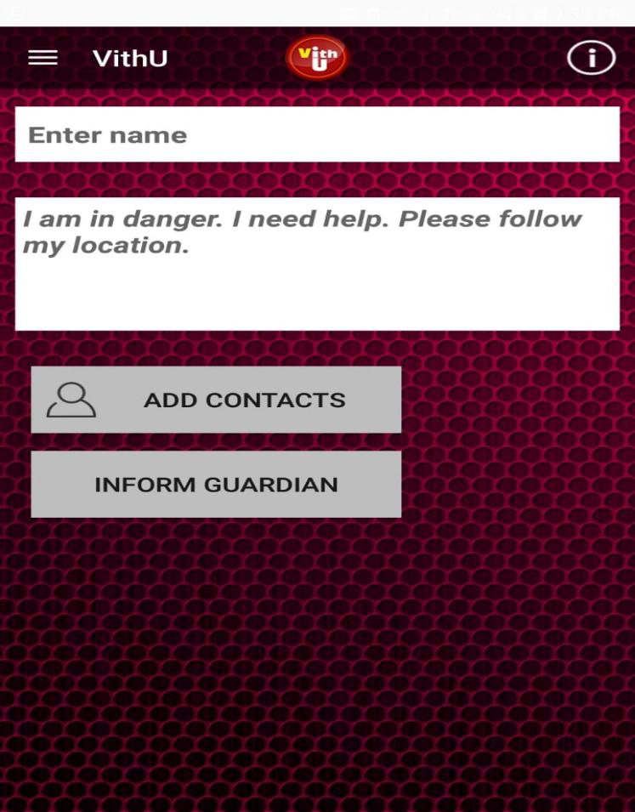

**Figure 1 VithU App**

#### 1.6.2. Circle of 6 App:

This app has different notifications that the user can tap on to alert their circle. If you need a safe ride home or for a familiar face to turn up and take you away from a strange environment, this app will help send an alert to any of your 6 chosen contacts. On top of that, the app can connect you to the proper authorities for an emergency, or even just for relationship advice

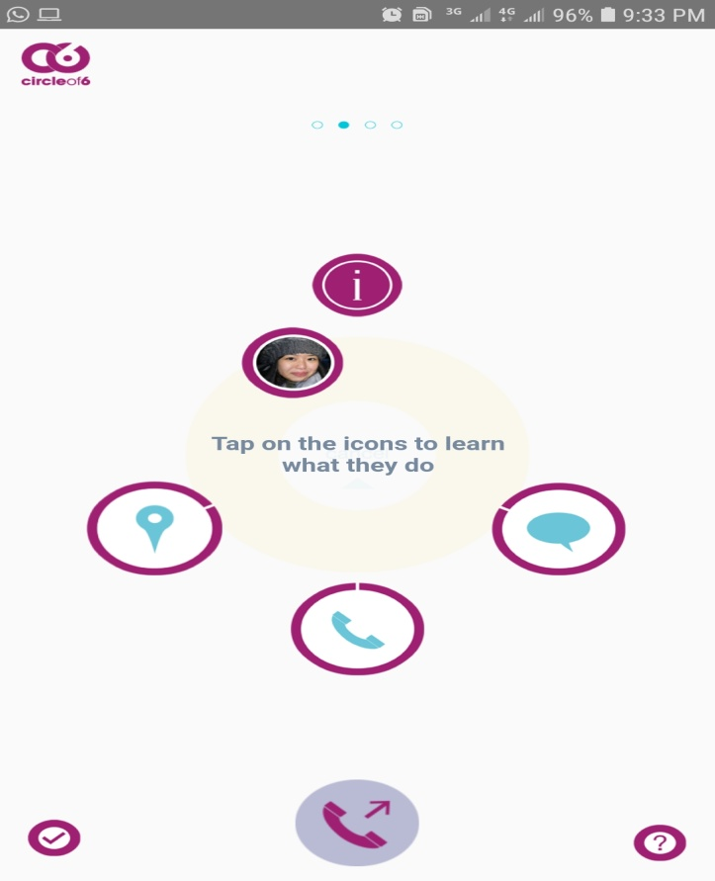

Figure 2 Circle of 6 App

**How our application is not the same as its related work:**

This proposed system is GPS based “Human Protection System". It includes of GPS device for example any Android Phone. The device will give the position data, for example, scope, longitude of the client. And also it is different from other it works without Internet when Internet is not available.

# 1.7. Methodology and Software Lifecycle for This Project

The fundamental and building block of a project is to describe the methodology. The methodology is essential for managing the project. We make an all-around considered structure record, there are a few highlights that despite everything do not give a similar impact as it gave on the paper. During the execution stage, numerous highlights are included or altered. One needs to make a few changes in system design and requirement analysis. For creating of "Human Protection", we have chosen a flexible model type that can be molded easily after designing. Used as an agile development methodology for the development of our model.

# 1.8. The rationale behind Selected Methodology

Agile development is an interactive software development strategy that involves cooperation and self-organizational cross-functional teams. This involves the delivery of the project incrementally rather build and deliver the whole project at once. We have to deliver a progress report to the supervisor on an incremental basis and on that we gradually develop this application. Henceforth, agile is a combination of methodology and technique.

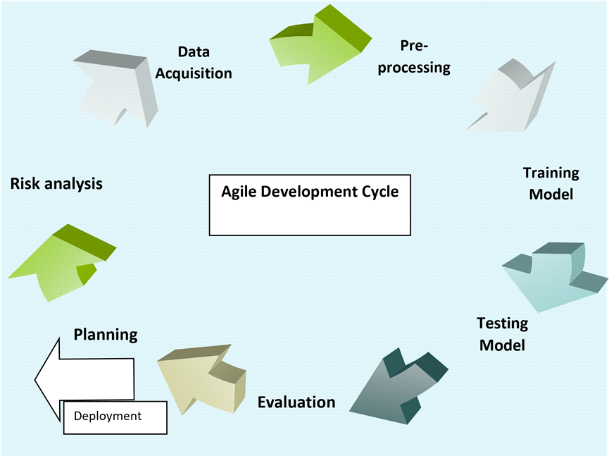

Figure 3 Agile model

**Chapter 2**

**PROBLEM DEFINITION**

# 2. Problem Definition

# 2.1. Problem statement

The major reason behind developing the human protection app is to facilitate human. In new application we are giving an easy to understand interface where the client could send the message ready all the more capable and smartly. The user couldn't need to recollect all the important contact numbers of relatives, family members or friends. The new system is additionally intelligent to the users and gives the office to realize their close by police station, and their own location.

**2.2. Deliverables and Development Requirements**

When we launch our application, users visit our application and know about the features of the human protection app the user must know about some basic knowledge that they can understand easily. While developing the Applications, we use android studio for developing our screens. User will see all of the following features in our application

## 2.2.1. User Interface

Android application is developed through which:

* User registration
* Friend registrations
* Get Instructions
* View Registered Friend

## 2.2.2. Development Requirement Including Following Software Requirement

### 2.2.2.1. Front end

Android studio (XML)

### 2.2.2.2. Back end

Database: SQLITE

Programming Languages: Java, XML

**CHAPTER 3**

**Requirement Analysis**

# 

# 3. Requirement Analysis

# 3.1. Use case Diagram(s):

It is the representation of the user with the system. It is used to describe the use cases (set of different actions) that can be performed by the actors (external users) by using the system. With the help of the use case, you can visualize the behavior of the system when the user uses it.

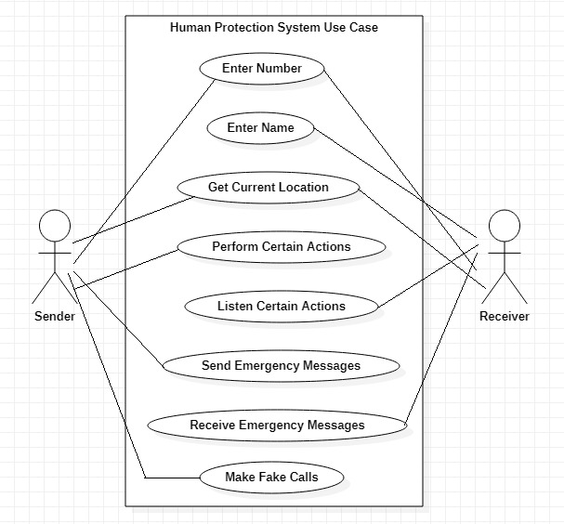

Figure 4 Use case diagram

**3.2. Detailed Use case**

## 3.2.1. Number

Table3.1 Enter Number

|  |  |
| --- | --- |
| **Use-case name** | Enter Number |
| **Actor** | User |
| **Description** | User will Register his/her Number. |
| **Pre-condition** | Open Application. |
| **Post-condition** | The user should get the desired outcome. |

## 3.2.2. Register Member

Table3.2 Register Member

|  |  |
| --- | --- |
| **Use-case name** | Register |
| **Actor** | User |
| **Description** | The user has to registered member (Name, Number). |
| **Pre-condition** | Users must be using the application. |
| **Post-condition** | The user should get the desired outcome. |

## 

## 

## 3.2.3. Get Location

Table 3.3 Use-Case (Get Location)

|  |  |
| --- | --- |
| **Use-case name** | Get Location |
| **Actor** | User |
| **Description** | The user will get current location and can send to registered members. |
| **Pre-condition** | User must have to Internet and GPS on. |

## 3.2.4. Send Emergency Message

Table3.4 Send Emergency Message

|  |  |
| --- | --- |
| **Use-case name** | Send Emergency Message |
| **Actor** | User |
| **Description** | The user will send emergency message to registered number if he/she is in trouble. |
| **Pre-condition:** | User must have sim card, balance, mobile data(internet) etc. |

## 

## 3.2.5. Receive Emergency Message

Table3.5 Use Case (Receive Emergency Message)

|  |  |
| --- | --- |
| **Use-case name** | Receive Emergency Message |
| **Actor** | Registered Member |
| **Description** | Registered member get emergency message when user shake mobile. |
| **Pre-condition** | Receiver number must be registered. |
| **Post-condition** | SMS received. |

## 3.2.6. Make Fake Call

Table3.6 Use Case (Fake Call)

|  |  |
| --- | --- |
| **Use-case name** | Make Fake Call |
| **Actor** | User |
| **Description** | There is option/button when user will press fake call alarm executed. |

# 3.3. Functional Requirements:

Functional requirements are those functionalities that software must offer. It describes the basic behavior of the software. Functional requirements should include the details of functionality or operations provided by each screen. The complete workflow of the software should be made clear.

The following are the functional requirements of this project.

## 3.3.1. Fake Call:

When user will be in trouble then he/she press fake call button to get fake call to give fear to thief.

## 3.3.2. Siren voice:

User can get siren voice like police and men voice by press siren button.

## 3.3.3. Location Finder:

User can get current location

**3.3.4. Message Sending:**

User can send message to friend by shaking mobile showing that he/she in trouble.

# 3.4. Non-Functional Requirements:

Non-functional requirements show that how the system should perform certain functionality. Non-functional requirements generally deal with the quality of the software. Following are the non-functional requirements of this system:

Table 3.7 Non-Functional RE#01

|  |  |
| --- | --- |
| **Name** | **Performance** |
| **Summary** | Performance defines how efficient is the application |
| **Requirement** | The Human Protection App will be good in a performance like it will help the user to find location, send information to registered contact via SMS. |

Table 3.8 Non-Functional RE#02

|  |  |
| --- | --- |
| **Name** | **Portability** |
| **Summary** | Portability means when using an application user is not restricted to use it by sitting on a fixed place or it does not need a different system to operate |
| **Requirement** | It will be in your android mobile phone. |

Table 3.9 Non-Functional RE#03

|  |  |
| --- | --- |
| **Name** | **Usability** |
| **Summary** | By usability of software, you mean that it should be easy to learn. The user should not feel any difficulty in using this system |
| **Requirement** | In Human Protection App, we have included this in our priorities that this application should be user friendly, moreover it should not be complex in its working mechanism |

Table 3.10 Non-Functional RE#04

|  |  |
| --- | --- |
| **Name** | **Compatibility** |
| **Summary** | It means to ensure that customer is satisfied or not by testing. |
| **Requirement** | This application is compatible with the android operating system; it is being designed for specifically android OS. |

Table 3.11 Non-Functional RE#05

|  |  |
| --- | --- |
| **Name** | **Maintainability** |
| **Summary** | In which component can be modified to improve performance. |
| **Requirements** | The requirement of maintainability is easily achieved in this application because all the basic record of the application is saved in the database. |

**CHAPTER 4**

**Design and Architecture**

# 

# 4. Design and Architecture

Following are the software diagrams of our project along with their descriptions.

# 4.1. System Architecture

A set of concepts that are a part of the architecture, including principles, elements, and components is known as a graphical representation. Our architecture consists of 2 main modules; Frontend, and backend. The front end is an interactive interface that allows users to visit our application. Users can send information to register friend via sms and this information include latitude and longitude of user current location. The overall architecture will explain the overall view of the developing model. Our project architecture diagram is given below.

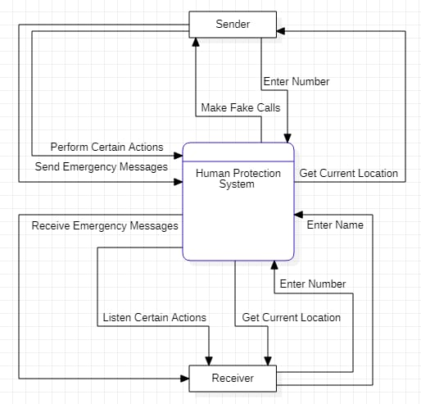

Figure 5 System Architecture

## 4.1.1. Description

This diagram explains how the overall interaction between user and application takes place. A user interacts using the android interface which is used to control the whole process and background processing. The application gets input through mobile shaking, power button three time presses, Google map. Users can add friend for messaging sending in trouble.

# 4.2. Data Representation [Diagram +Description]

It contains different symbols & connectors. It is known as graphical representations between people and objects. An ER model is made of an entity and some specific relationships which exist between entities.

**4.3. Process Flow [Representation]**

It is a way of representing the flow of data through the system. It provides information about the outputs and inputs of entities and processes. It shows a complete flow of data between system modules. The application will take input i.e. name, number from the user, and shows functionalities. Following is a data flow diagram of the Human Protection System app

# 4.4. Process Flow Representation:

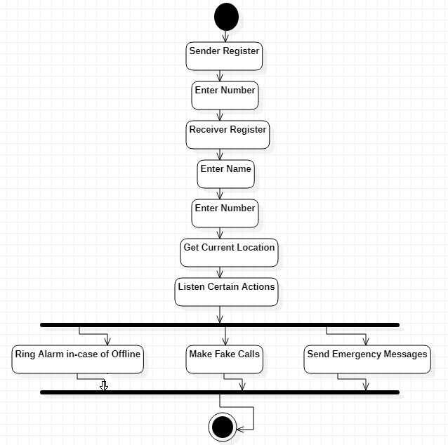

Figure 6 Process Flow

## 4.4.1. Description

The figure demonstrates the data process of the overall system that how a user will operate our application. Firstly user registered their number then registered emergency contact. Also user can get current location and can perform certain action like fake call, ring alarm, emergency Message etc.

**4.5. Sequence Diagram Representation:-**

**4.5.1. Sender End:**

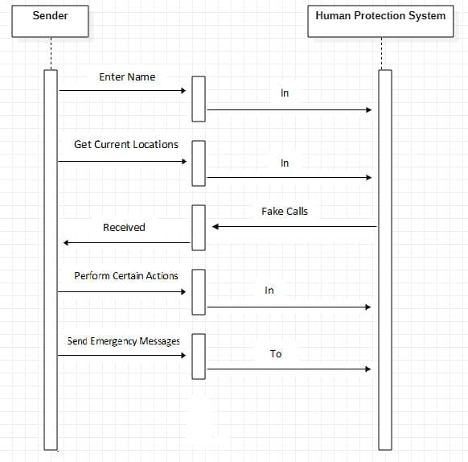

Figure 7 Sequence Diagram

**4.5.1.1. Description:-**

This Diagram shows the full structure of sender End .It shows sender interactions arranged in time sequence. It depicts that sender involved in this scenario like enter their name when start to use the App ,get exact location, fake call option, many other functions and send messages to friends list.

**4.5.2. Receiver End:**

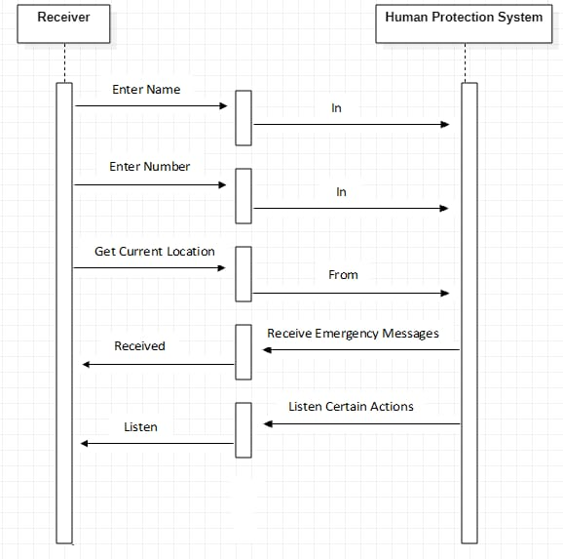**Figure 7.1 Sequence Diagram**

**4.5.2.1. Description:-**

This Diagram shows the full structure of receiver End .It shows receiver interactions arranged in time sequence. It depicts that receiver involved in this scenario like receive friends name and number, received exact location, many other functions and received messages from emergency numbers.

**4.6. UML Diagram Representation:-**

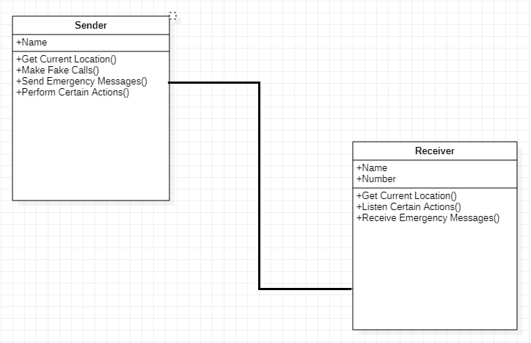

**Figure 8 UML Diagram**

**4.6.1. Description:-**

The figure explains the data process of the overall system that how a user will operate our application. Firstly user registered their name then registered emergency contact. Also user can get current location and can perform certain action like fake call, ring alarm, emergency Message and at the receiver End received messages and location of vitamins with their name and number etc.